The Occasional Diamond Thief and The Salarian Desert Game

By Author J. A. McLachlan
Occasional
The ^ Diamond Thief
16-year-old Kia must learn the secret behind the magnificent diamond her father gave her on his deathbed - without letting anyone know she has it.
"J. A. McLachlan is a terrific writer -- wry and witty, with a keen eye for detail. I've been following her work with interest and delight since 2003. In a world where young-adult fiction is booming, The Occasional Diamond Thief propels McLachlan to the front of the pack." ~ Robert J. Sawyer
"Tense, thrilling, edge-of-the-seat reading--I tore through these books! Kia and Agatha are a fascinating pair, Kia so practical, down-to-earth, and wilful; Agatha so mystical and driven.
More, please!" ~ Tamora Pierce
"Strong, character-driven Science Fiction -- McLachlan makes you both care and think. You can't ask for more. I enjoyed both books in this series, and hope to see a third." ~ Tanya Huff
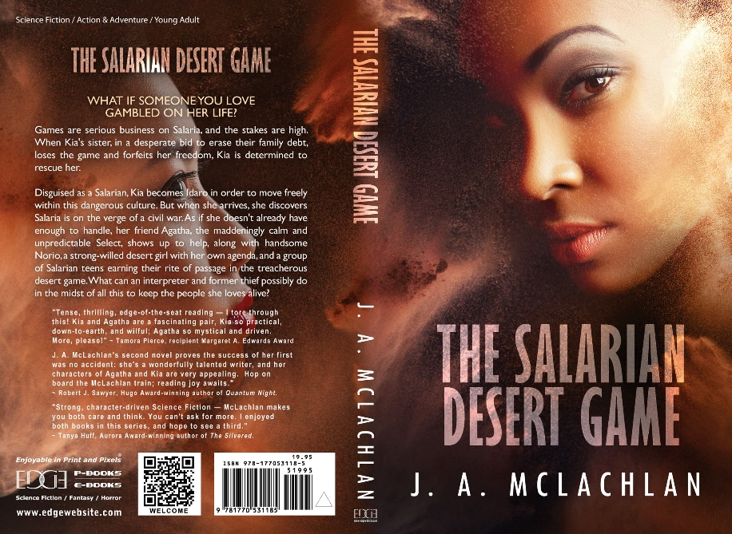
The Salarian Desert Game
When Kia's sister loses her freedom in a game of Salarian Die, Kia travels to Salaria disguised as a Salarian girl named Idaro, risking her life to save her sister.
"J.A. McLachlan's second novel proves the success of her first was no accident: she's a wonderfully talented writer, and her characters of Agatha and Kia are very appealing. Hop on board; reading joy awaits." ~ Robert J. Sawyer

